FBeye Quick Start Guide: (caution – incomplete)

1. Make sure your X11 settings are correct (if on a Mac):  
   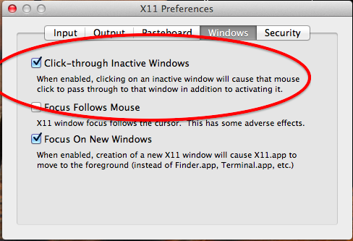
2. Download the data from Jim’s email
3. Download the .tar.gz or .zip file for FBeye
4. Unpack FBeye directory in your IDL directory
5. Download and unpack the jrad IDL package in your IDL working directory
6. You should now be able to run IDL and launch FBeye like so:

Fuji:Users:james:Desktop:Screen Shot 2013-08-10 at 11.29.51 PM.png

then enter the file name (with no quotation marks)

OR launch FBeye with the file explicitly named:

Fuji:Users:james:Desktop:Screen Shot 2013-08-10 at 11.32.19 PM.png

Note: if a file with this *same name* has been used before, it will ask if you if you want to assume the old results. **This is how you resume work on an old file**, simply enter the old file name and say yes (the default).

You should now see the main FBeye working screen

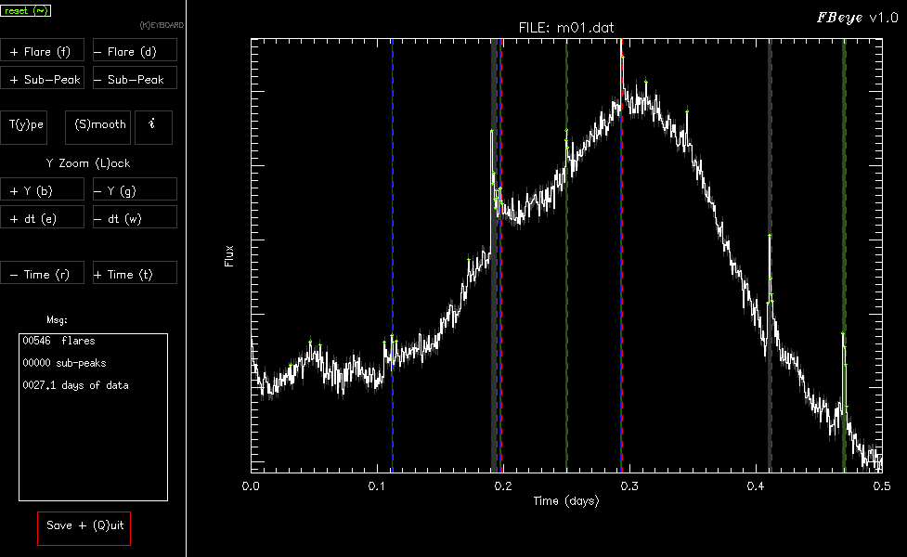

**Primary Goals:**

* **Identify every flare you can in the lightcurve,**
* **make sure the start/stop times are accurate, and**
* **ensure the classical vs complex flares are typed**

FBeye automatically finds flares and assigns basic classifications to them. For the Kepler 1-min cadence data it is able to fairly robustly find most classical flares. Start/Stop times are often a bit wrong, and need to be adjusted.

“Type” classification is assigned using very simple rules:

* Most are “classical”
* If there is an *obvious* secondary peak it is classified as a “complex”

This is WAY too simple, and not robust**. Please adjust as you go!**

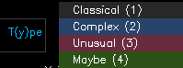 The TYPES are also color-coded

The display is broken in to 2 sections: buttons (left) and Lightcurve (right).

If you hit the “KEYBOARD” button, then all buttons can be operated using the keyboard commands (in parentheses next to each button name).



To add a flare, click [+ Flare], then follow instructions (click start then stop time in light curve).

Note: the program only cares about the time axis here, don’t worry about clicking ON the flare, but just the proper times

To remove a flare: click [- Flare] and then click anywhere within the errant flare.

To show the “Smooth” version (with spots/long term trends removed) click [Smooth]. This is using the “softserve” smoothing prescription only, and does have local smoothing artifacts due to flares themselves or gaps in time.

To find the info/stats about a flare, click [*i*] and then the flare of interest.

To move fwd/back in time along the lightcurve click [+ Time] and [- Time] respectively. The amplitude (flux) and time zoom can be adjusted with the [+/- Y]   
and [+/- dt] buttons, respectively. To force a zoom lock, click [Y Zoom Lock] (rarely used)

**If you resize the display, or otherwise mess the display up, the top left corner will always be the Reset button (or the ~ key if in KEYBOARD mode).**

When you are finished, or want to take a break, click [Save + Quit]

Note: every action you take in FBeye will be saved automatically in the FBeye tmp directory

When you are done: please send me the .fbeye file for each month of data, which will be present in your working directory.

Fuji:Users:james:Desktop:Screen Shot 2013-08-10 at 11.33.19 PM.png

**Tips:**

1. Don’t worry about flagging *every* positive flux deviation as a flare. There is noise/artifacts
2. Focus on making sure multiple flares are not contained as one flare event
3. Focus on making sure real complex events are flagged as **Complex**, and simple FRED (Fast Rise Exponential Decay) flares are typed as **Classical**